1)

i) The Merge lead is not ready, hence do not run it.

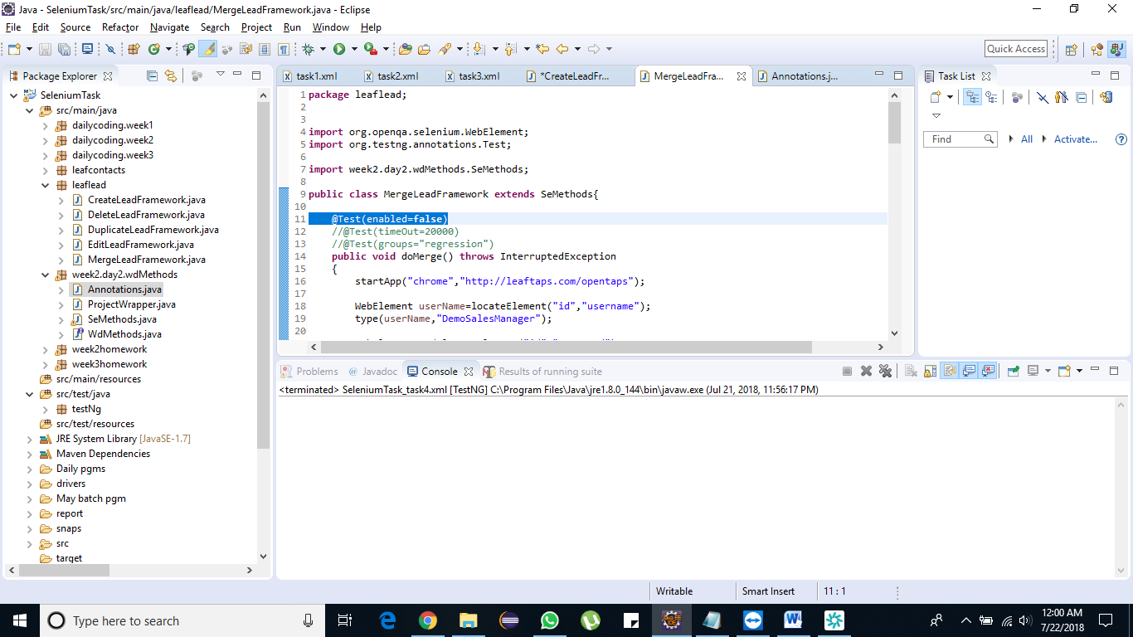

ii) The Create lead should run 2 times but the overall invocation should complete with 2 minutes

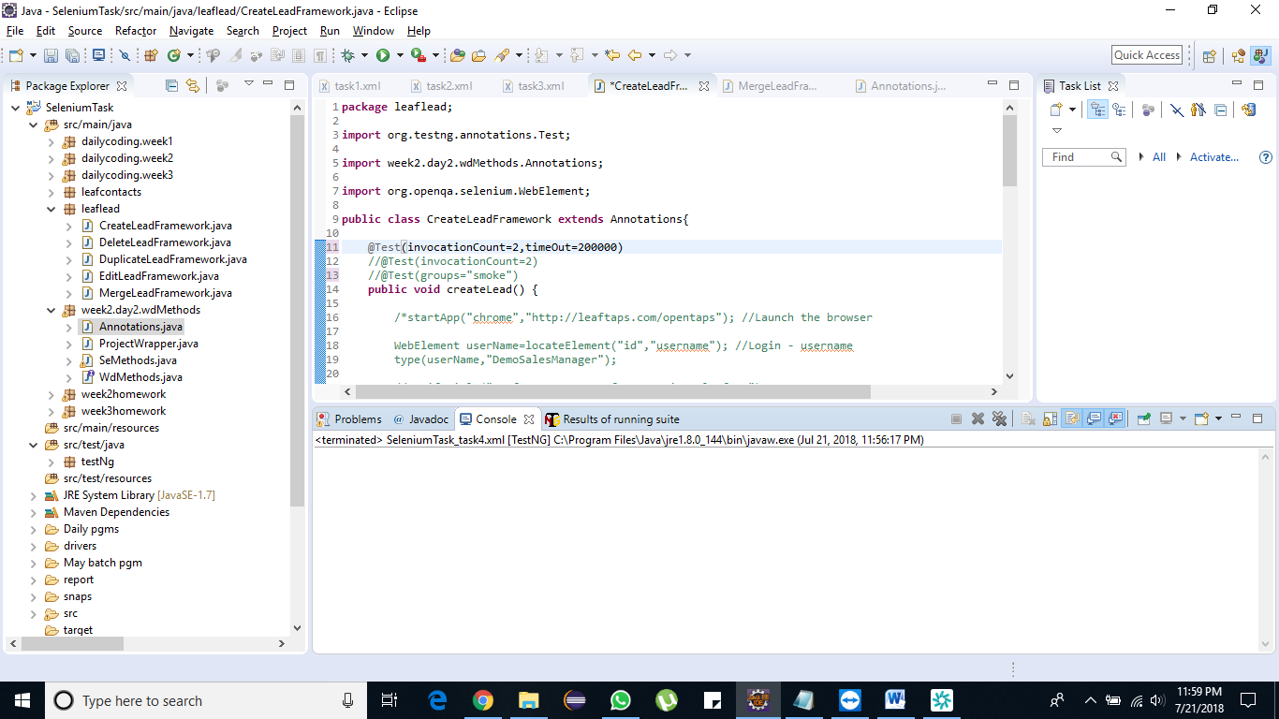

***Test ng xml:***

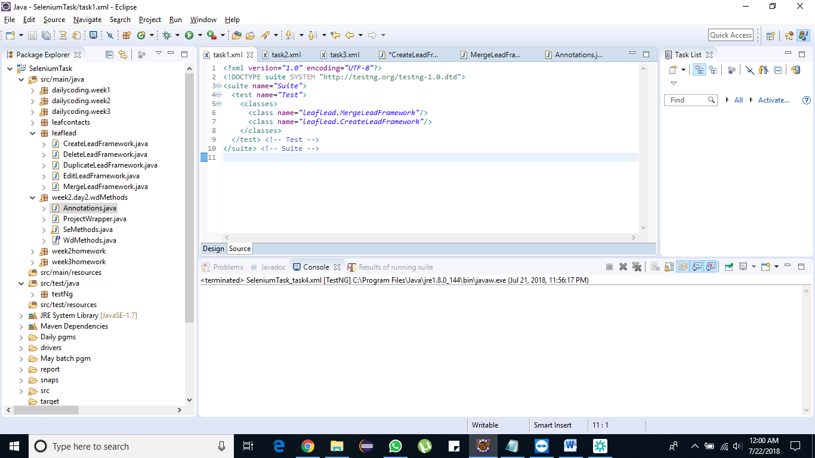

2)

i) Run testcase Create Lead, EditLead sequentially and DeleteLead, MergeLead are parallely.

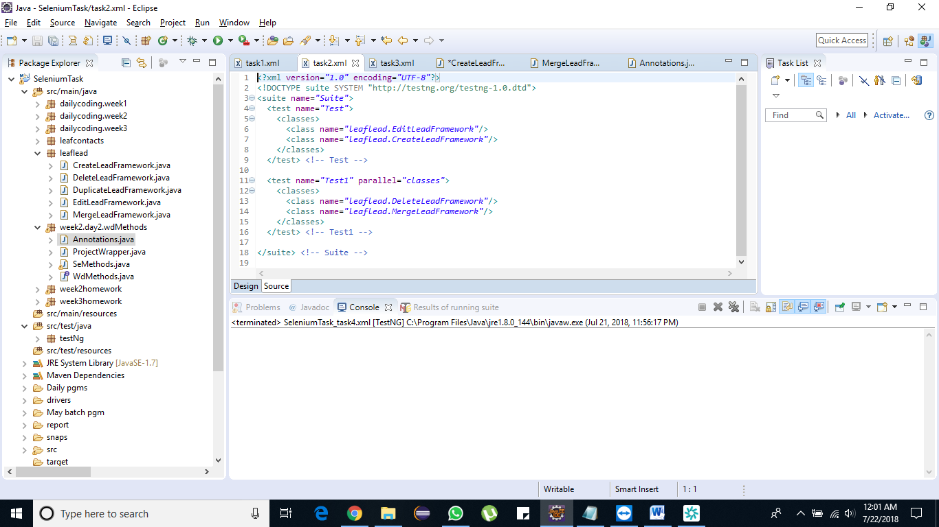

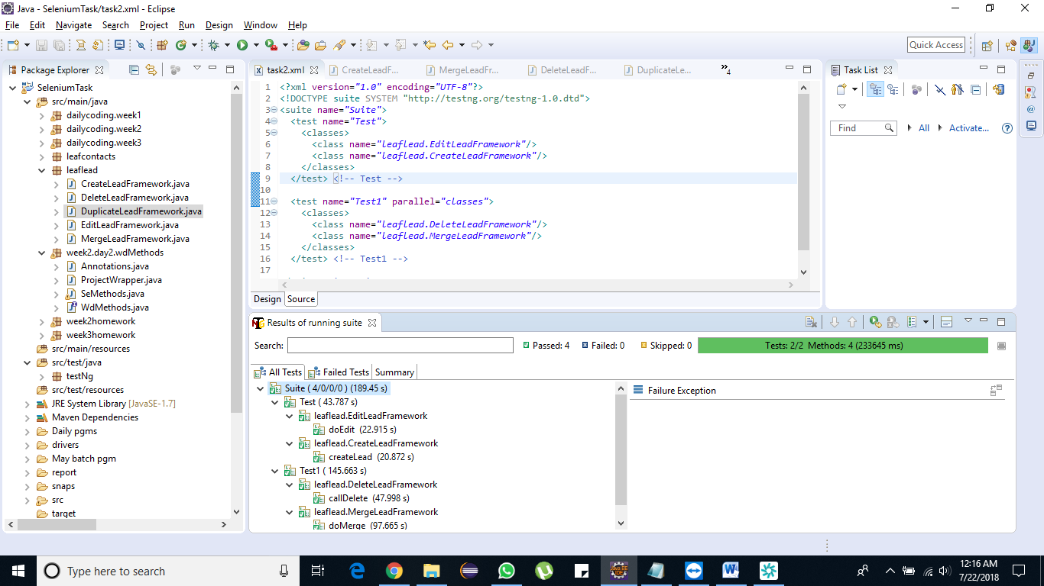

3)

a)EditLead and DeleteLead should be dependons on createLead,

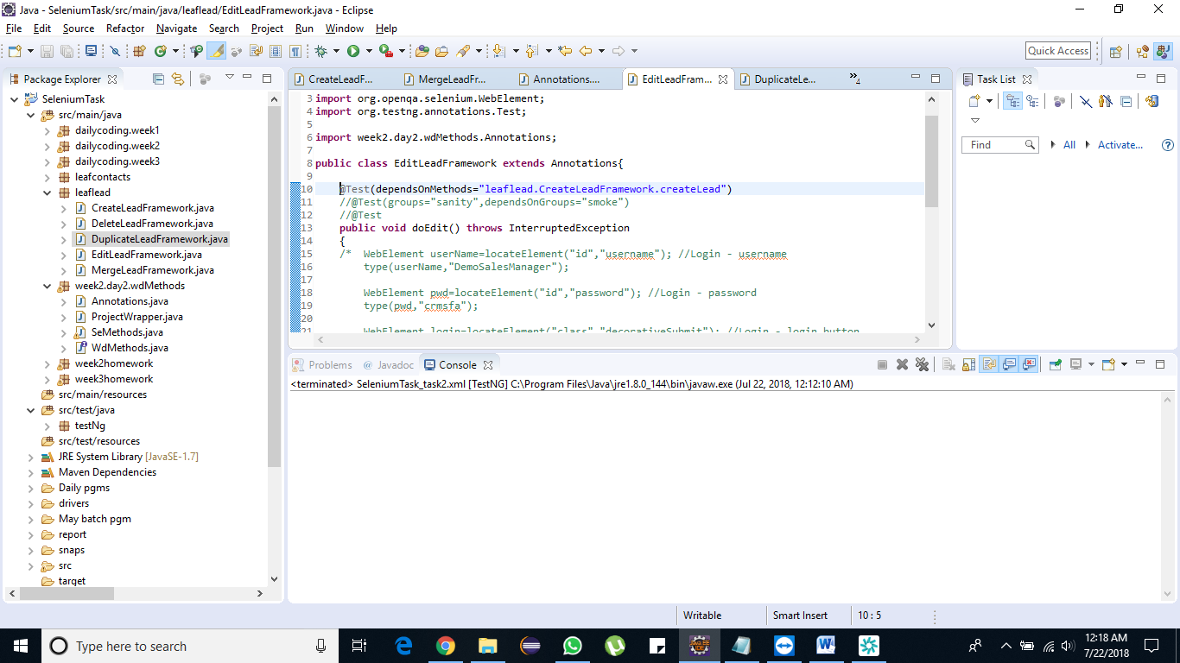

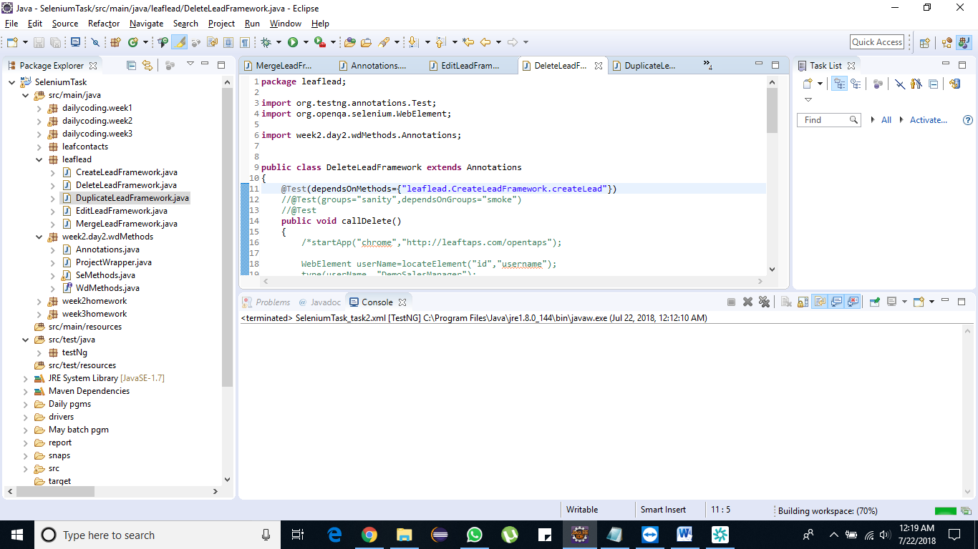

B) Duplicate Lead is not ready yet

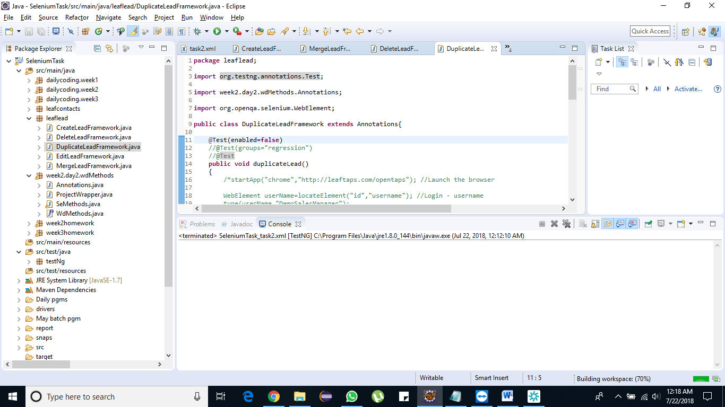

c) createLead should 2times

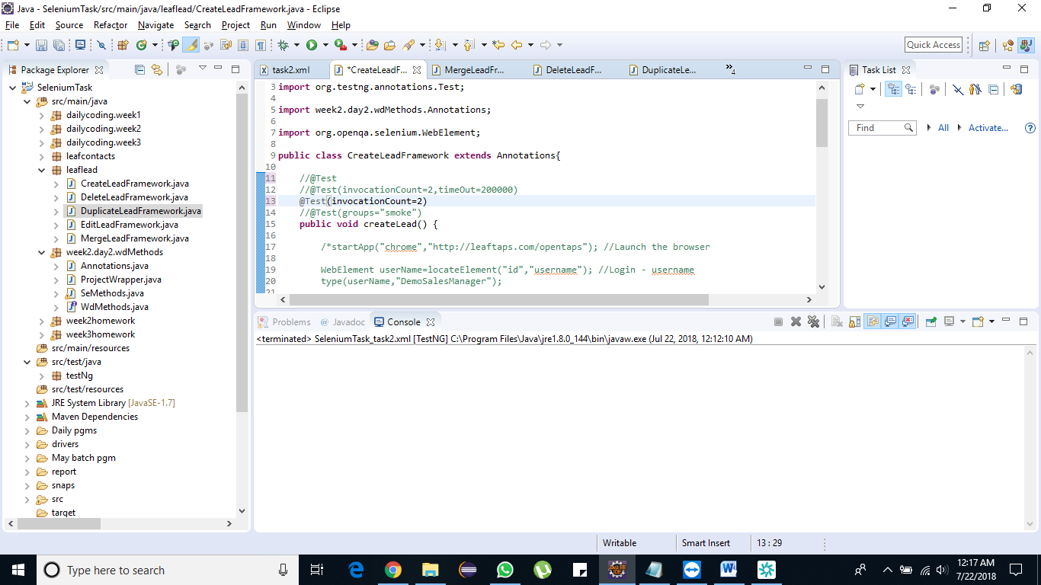

d) MeargeLead should completed within 20 sec

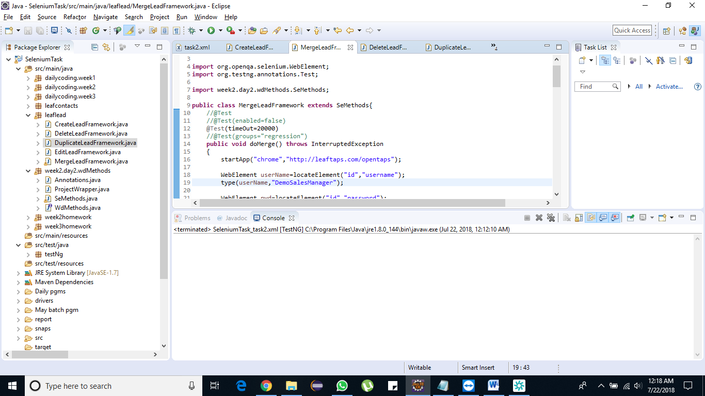

e) Run Create, Edit, Delete,Duplicate and MergeLeads in parallel for 2 Thread counts and bring the observation.

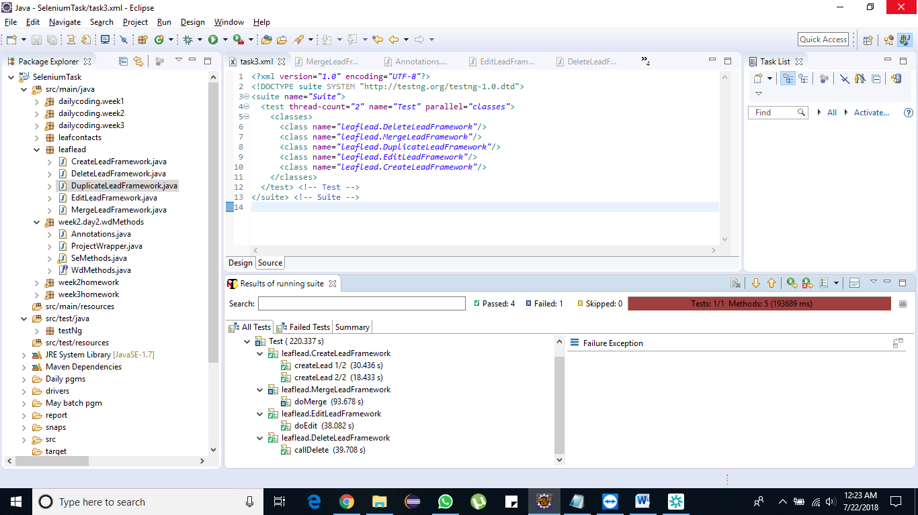

(merge lead fails due to the timeout reason)

4) Implement Groups

***Pre-requisite:***

• Test Case CreateLead should be part of the group1 (Smoke)

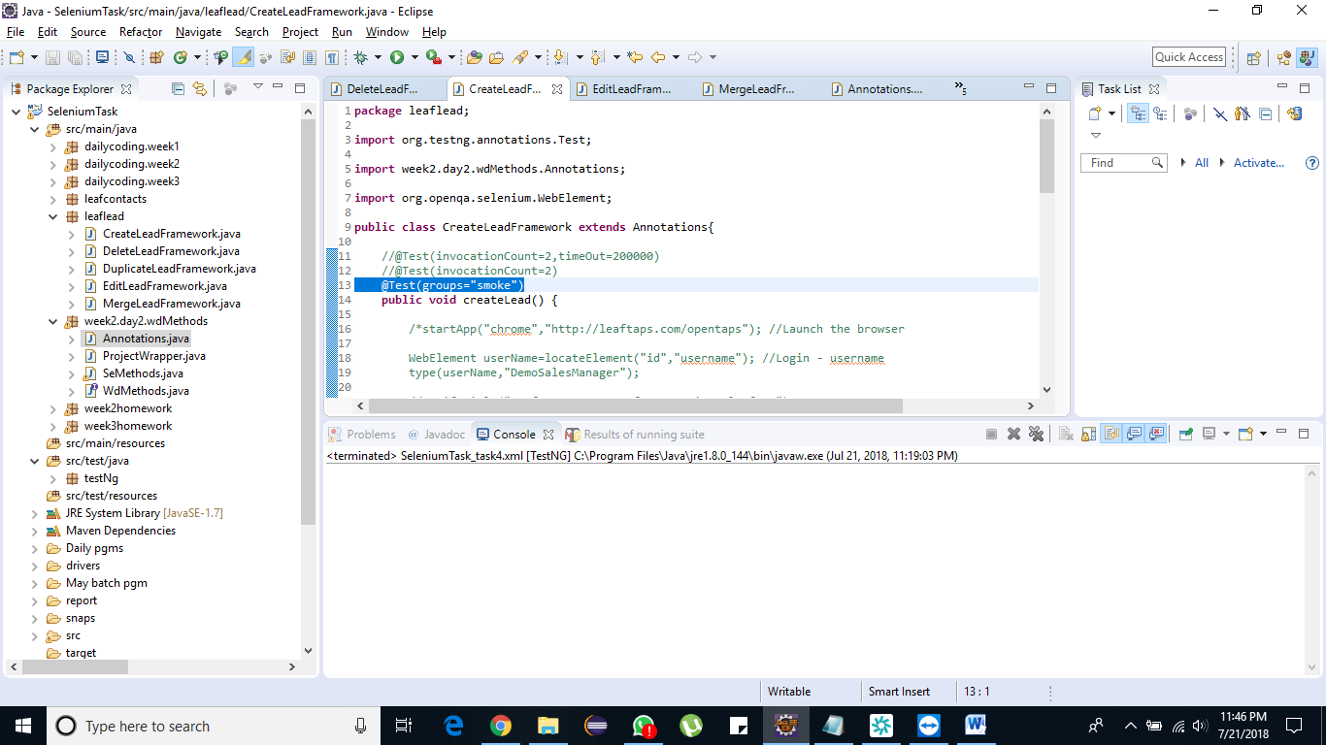

• EditLead and DeleteLead should be part of the group2 (Sanity)

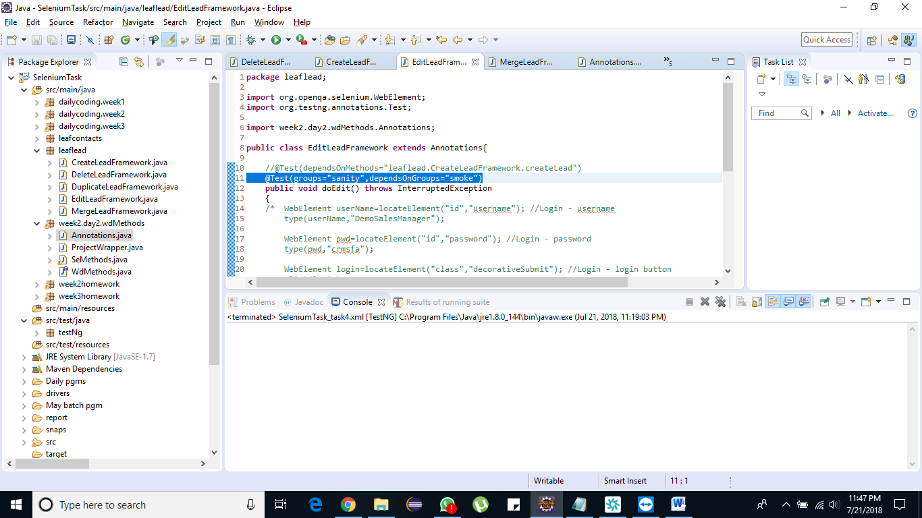

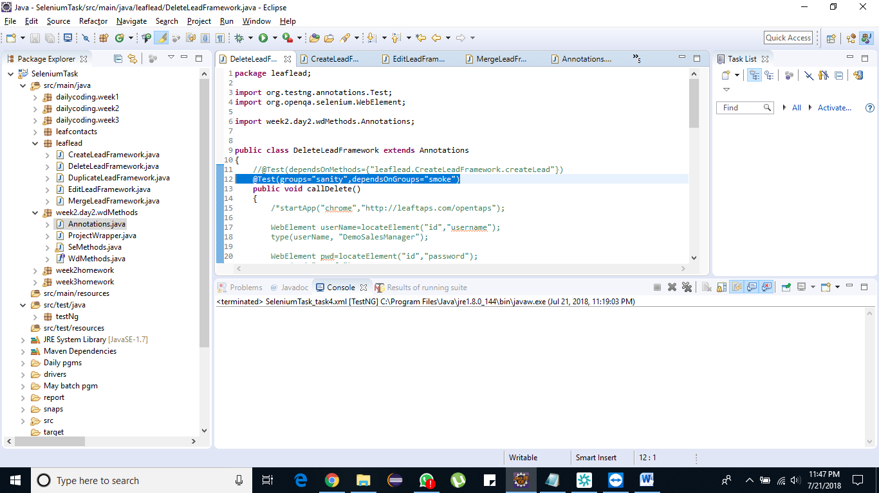

• Merge Lead and Duplicate Lead should be part of the group3 (Regression)

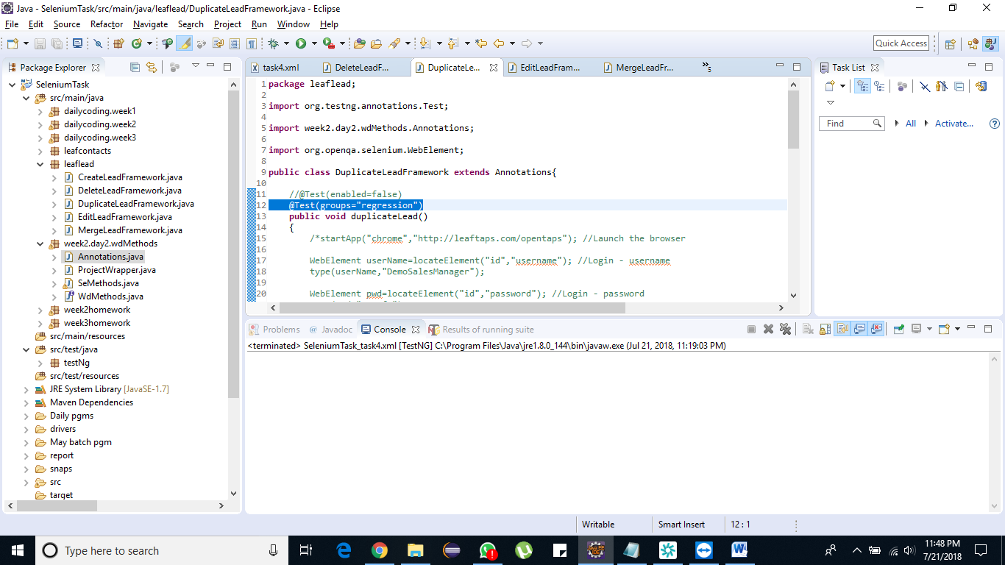

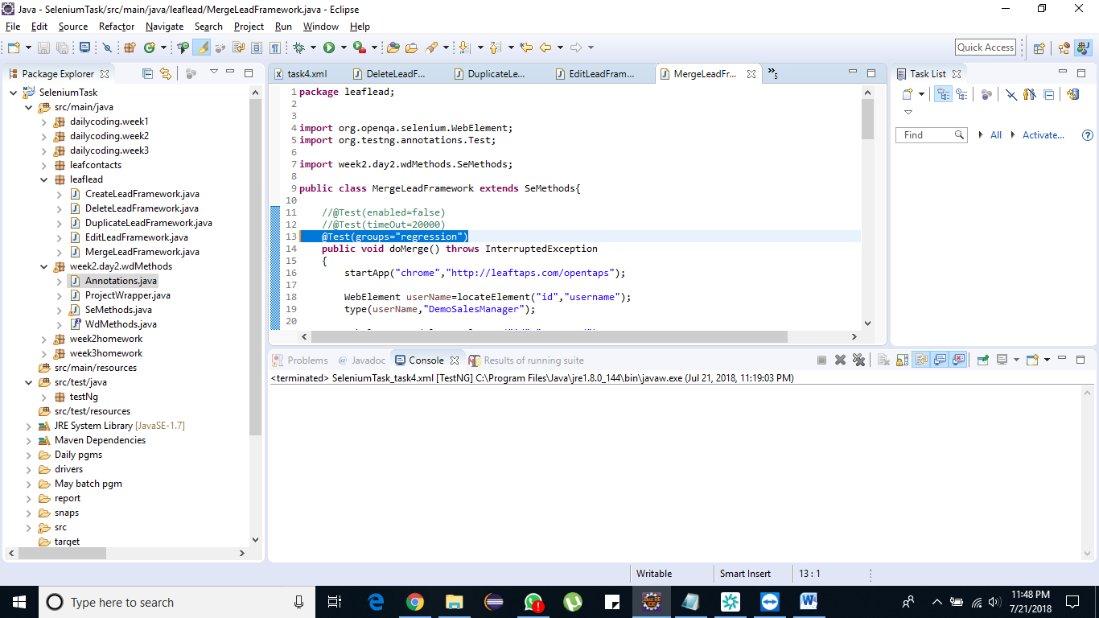

• Sanity should be depends on Smoke

1. Run both groups

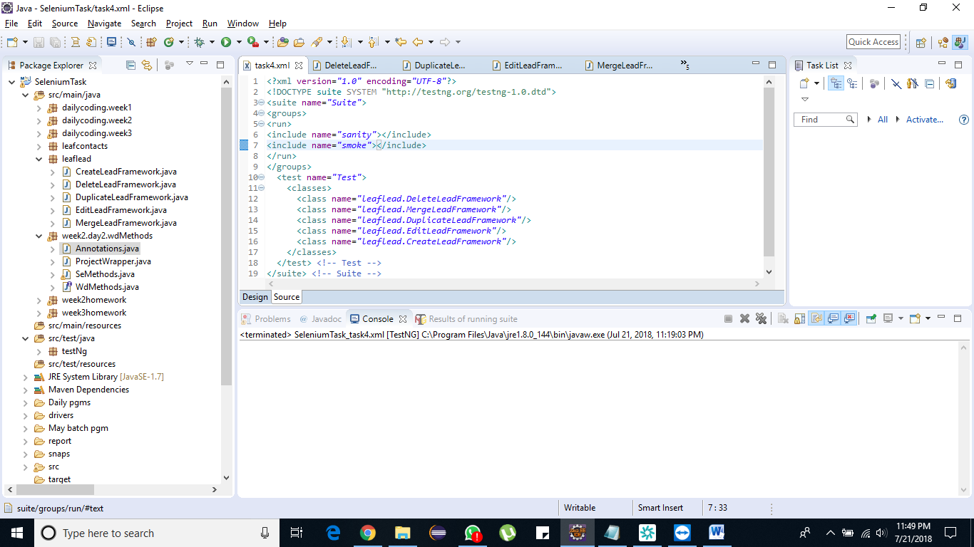

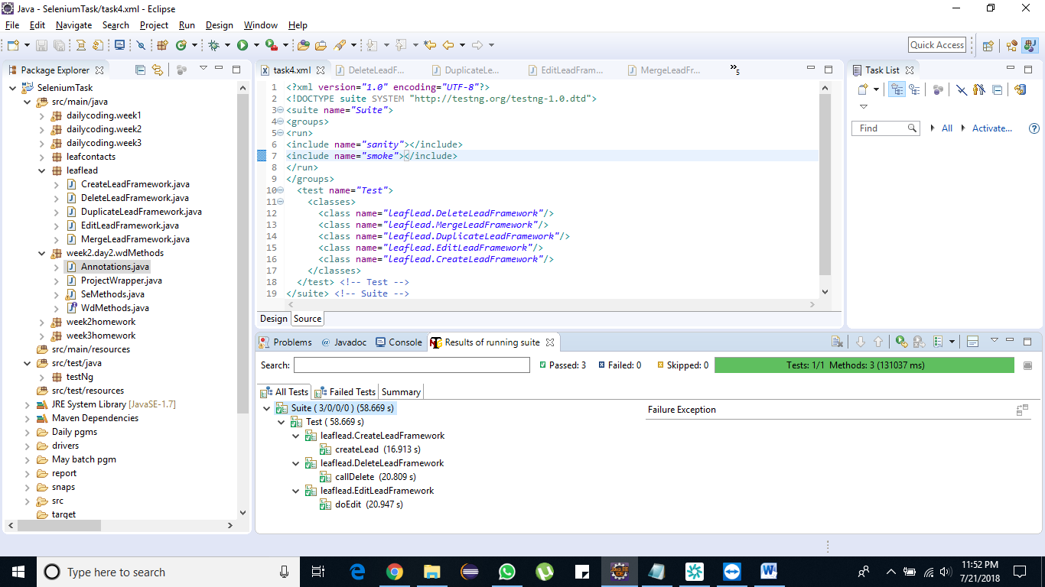

1. Run only Smoke

